

**UNIVERSITY OF KUALA LUMPUR**

**MALAYSIAN INSTITUTE OF INFORMATION TECHNOLOGY**

|  |  |  |  |
| --- | --- | --- | --- |
| **Name of Course** | Software Configuration Management (SCM) | **Course Code** | ISB42303 |
| **Lecturer** | | Ms. Nurul Sharaz Azmanuddin | |

|  |  |  |
| --- | --- | --- |
| **ID Number** | **Student Name** | |
| 52213116280 | MUHAMAD FAIZ BIN HISHAMMUDDIN | |
| 52213116286 | AFIQ IZZUDDIN BIN MOHAMAD BUKHAREE | |
| 52213116044 | SYED ZARUL ZAQUAN BIN SYED MUHAMAD ZULKIFLI | |
| 52213116292 | WAN MOHAMAD NAIMAN BIN WAN MAYU OTHMAN | |
| **Programme** | | BSE |
| **Submission Date** | | 22 March 2019 |

|  |  |
| --- | --- |
| **Assessment** | Mini Project |

Table of Contents

1.0 Introduction 2

2.0 Project Background 3

2.1 Problems/ Issues in the Existing System 3

2.2 Solutions Proposed 3

3.0 Objectives of Reuse 3

4.0 Project Scope 3

5.0 User of The System 4

5.1 Software/ Tools/ Hardware Used 4

5.2 Availability of Software / Hardware 4

6.0 Prototype Development 5

6.1 Explanations for every classes/ methods/ interface 7

7.0 Technology Used (Frameworks/Client Server/ Servlet/ JSP/ Database/ Text File/ SQL Query/ Programming Language) 8

8.0 Future Recommendations/ Suggestions 8

9.0 Summary/ Conclusion 8

10.0 Appendix e.g. Program Source Codes 8

11.0 References ( Books/ Web Sites (when is your last accessed??) / Journals etc. ) //recommended to use Mendeley 8

# 1.0 Introduction

The clothing and fashion industry calls for an eye-catching, trendy and stunning online presence. Sneakers that is limited is included in this clothing and fashion industry. The limited edition of these brand clothing nowadays is on rise. The Llama Plug is a system that is made for selling these limited-edition brand clothing around the world.

# 2.0 Project Background

Llama Plugin is a system that was built for the people that is interested in finding this kind of limited-edition brand clothing. The website will gather the collector of the sneakers for selling and buying the clothes.

# 2.1 Problems/ Issues in the Existing System

The issues and problems in the existing system has made the system unusable for today millennials because of the problems that has not been resolved. One of the problem is that, the seller that uses this system cannot put any quantity for selling their product, thus the buyer will not know the remaining stock they have. The system is not suitable for mobile view since most of the people uses a smartphone for a variety reasons. The lack of design interface is not user friendly and the user of the system will have an impression that the system is old for global uses.

# 2.2 Solutions Proposed

Problems and issues that occurred on the system can be solved by the proposed solutions.

1. Implement QR code features for the user to view the available product.
2. Implement a mobile view features for the website.
3. Implement “add quantity” features for the product so that the buyer will know the remaining stock of the product.

# 3.0 Objectives of Reuse

The reuse of this system is to implement the necessary features for the user to make in convenience to use.

# 4.0 Project Scope

The Llama Plug is developed and improved based on the existing system that can be maintained and suitable for the user. The developed system will have the features based on the targeted audiences experience.

# 5.0 User of The System

1. Admin
   1. Add members
   2. View members
   3. Delete members
   4. Maintenance
2. Member
   1. Add, delete, view product
   2. Add, delete, view quantity
   3. Add, delete, view sizes

# 5.1 Software/ Tools/ Hardware Used

Software

1. Notepad++
2. XAMPP

Hardware

1. Processor : Intel(R) Core(TM) i5-3210M CPU @ 2.50GHz
2. 10 GB RAM
3. 64-bit operating system

# 5.2 Availability of Software / Hardware

1. The website is available for 24/7.
2. The hardware is available for computer, smartphone, or tablet.

# 6.0 Prototype Development

Waterfall approach was first SDLC Model to be used widely in Software Engineering to ensure success of the project. In "The Waterfall" approach, the whole process of software development is divided into separate phases. In this Waterfall model, typically, the outcome of one phase acts as the input for the next phase sequentially.

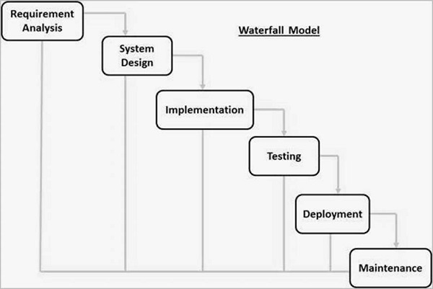

1. Requirement Gathering and analysis − All possible requirements of the system to be developed are captured in this phase and documented in a requirement specification document.
2. System Design − The requirement specifications from first phase are studied in this phase and the system design is prepared. This system design helps in specifying hardware and system requirements and helps in defining the overall system architecture.
3. Implementation − With inputs from the system design, the system is first developed in small programs called units, which are integrated in the next phase. Each unit is developed and tested for its functionality, which is referred to as Unit Testing.
4. Integration and Testing − All the units developed in the implementation phase are integrated into a system after testing of each unit. Post integration the entire system is tested for any faults and failures.
5. Deployment of system − Once the functional and non-functional testing is done; the product is deployed in the customer environment or released into the market.
6. Maintenance − There are some issues which come up in the client environment. To fix those issues, patches are released. Also to enhance the product some better versions are released. Maintenance is done to deliver these changes in the customer environment.

# 6.1 Explanations for every classes/ methods/ interface



# 7.0 Technology Used (Frameworks/Client Server/ Servlet/ JSP/ Database/ Text File/ SQL Query/ Programming Language)

Programming language :

* PHP
* SQL
* Bootstrap
* CSS

Database :

* XAMPP MySQL

# 8.0 Future Recommendations/ Suggestions

The development of mobile application for Llama Plug.

# 9.0 Summary/ Conclusion

To have a successful software project, it is essential to identify what constitutes success. Project success and failure is a subject of perception and that the criteria could vary from project to project. A project that has been perceived to be a failure by one stakeholder may be perceived as a success by another. Knowledge and understanding of success and failure factors, as well as, how to measure them and the interactions between these factors have great importance for project management effectiveness.

# 10.0 Appendix e.g. Program Source Codes

# 11.0 References ( Books/ Web Sites (when is your last accessed??) / Journals etc. ) //recommended to use Mendeley